Improving Food Security in Sri Lankan Schools: An
Evaluation of Food Donation System

D.I.De Silva
Department of Computer Science and Software Engineering
Sri Lanka Institute of Information Technology. (SLIIT).
Malabe,SRI LANKA
dilshan.i@sliit.lk
H.M.C.D Samaraweera
Department of Computer Science and
Software Engineering
Sri Lanka Institute of Information
Technology. (SLIIT). Malabe,SRI LANKA chalithdinushansamaraweera@gmail.com
W.A.C Pabasara
Department of Computer Science and Software Engineering
Sri Lanka Institute of Information Technology. (SLIIT).
Malabe,SRI LANKA
chamali.p@sliit.lk
W.S.D Thenabandu
Department of Computer Science and
Software Engineering
Sri Lanka Institute of Information
Technology. (SLIIT). Malabe,SRI LANKA shamildeshan121@gamil.com
S.A.N Wimalasooriya
Department of Computer Science and Software Engineering
Sri Lanka Institute of Information Technology. (SLIIT).
Malabe,SRI LANKA
nuwantha2000w@gmail.com
B.A.D.K.M Balachandra (Corresponding Author)
Department of Computer Science and Software Engineering
Sri Lanka Institute of Information Technology. (SLIIT).
Malabe,SRI LANKA
kolithamalan@gmail.com

M.G.R Pasan
Department of Computer Science and Software Engineering
Sri Lanka Institute of Information Technology. (SLIIT).
Malabe,SRI LANKA
ravindupasan34@gmail.com

Keywords: Food donation system, economic crisis, Sri Lanka, school children, Doneness

Abstract— Any individual living in society need to satisfy their individual needs, supplying of quality food is one of the primal requirements of one of those needs. However, there are many privileged people in any society who are capable of satisfying their needs and some who don’t. In such environments there are people who are willing to aid (donors) and the people who are longing to accept the help (donees). These both parties required a trustworthy platform to facilitate their needs. On this research the main focus is to analyze the government schools in Sri Lanka provincially. Surveys are conducted to analyze data and to aid to arrive conclusions. In addition to that it was necessary to fulfill the requirement of having a stabilized centralized trustworthy platform where both parties can interact securely.

Introduction

Overview
Adequate and nutritious food is essential for children's physical and mental development, especially those living in poverty. However, impoverished schoolchildren in Sri Lanka commonly face food insecurity due to a range of socioeconomic situations. To address this issue, numerous organizations and individuals donate food to underserved schools. However, little research has been conducted into the effectiveness of Sri Lanka's current food donation scheme for impoverished schools. The goal of this study was to fill a research gap by evaluating the food donation system for disadvantaged schools in Sri Lanka.
privileged people in any society who are capable of satisfying their needs and some who don’t. In such environments there are people who are willing to aid (donors) and the people who are longing to accept the help (donees). These both parties required a trustworthy platform to facilitate their needs. On this research the main focus is to analyze the government schools in Sri Lanka provincially. Surveys are conducted to analyze data and to aid to arrive conclusions. In addition to that it was necessary to fulfill the requirement of having a stabilized centralized trustworthy platform where both parties can interact securely.

Problem
The problem addressed in this study is the efficiency of Sri Lanka's food donation system in addressing the nutritional needs of school pupils. The study's specific goal is to examine the quality, quantity, and accessibility of donated food, as well as to highlight the issues that each province's food donation system faces.

Significance of the Research
This study is significant because it assesses the efficiency of the food donation system for poor schools in Sri Lanka and provides insights into the system's problems. The findings can help policymakers, donors, and other stakeholders improve the quality, quantity, and accessibility of donated food to meet the nutritional needs of poor schoolchildren.

Preview of the Remaining Sections
The paper will begin with a review of the research on food insecurity and the Sri Lankan food donation system. The methodology section will describe the mixed-methods strategy utilized to collect data from impoverished schools in Sri Lanka's nine provinces. The findings on the quality, quantity, and accessibility of donated food, as well as the issues faced by the food donation system in each province, will be presented in the results section. The discussion section will provide a critical analysis of the data as well as suggestions for improving the food donation system. The paper will finish with a discussion of the study's shortcomings and recommendations for future research.

Literature Review
Malnutrition is considered as one of the major issues in Sri Lanka as well as in World. When analyzing this situation, it possible to observe that considerable amount of school children does face such issues. As an example, one of the studies shows that there is a strong tether between malnutrition and pre-school children in Sri Lanka [1].
In Addition to that when a when a younger generation of a country suffers from a malnutrition it will directly affect the countries literacy and the economic status. Analyzing the facts [2], it is possible to realize that having a malnutrition community will eventually aid the Malnutrition cycle.
Although the benefits of food donations seem only affecting the unprivileged, that is not entirely true [3]. In some scenarios many has figured out that it does directly affects the environmental level by aiding to minimize food waste. Furthermore, considering the food industries available worldwide majority of them are not concerned about donating so that their researches conducted to encourage such organizations to do donations [4].
Moreover, many do have a common opinion that donor does not has any effect on donor when it comes to donations, which is false. Some researchers suggest any individual who participate as a donor do develop charitable behavior [5].
Most Of the donation related systems inherits a similar structure. Considering a system for stuff donation system it contains simple structure where admin, NGO, User exists as stakeholders [6]. Considering another web system to handle charitable trusts and NGO’s and it possess a similar structure where admin, NGO, orphanage exists [7]. In addition to that there is a blood donation system which uses revolutionize technology where NGO, User are the key stakeholders in the system. Moreover, there are applications which has both web and mobile view [8] which provides facilities for donors to donate.
Moreover, many do have a common opinion that donor does not has any effect on donor when it comes to donations, which is false. Some researchers suggest any individual who participate as a donor do develop charitable behavior [5].

Methodology
Evaluating the effectiveness of the underprivileged school donation web application includes a literature review of similar programs that have been implemented in Sri Lanka and other countries. The literature review aims to identify the impact of food donation programs on the nutritional status and academic performance of school children. The research methodology also includes a survey of users of the underprivileged school donation web application. The survey will assess the user experience, satisfaction with the system, and any suggestions for improvement.

Requirement Analysis

The first step in the implementation process is to gather the requirements for the web app. This will involve conducting a needs assessment with potential donors, school administrators, and other stakeholders to identify the key features and functionalities required in the web app.

Data collection: The data will be collected through a review of relevant literature, reports, and documents related to school donations and web app development. The study will also use qualitative data collection techniques such as interviews and focus group discussions with potential donors and other stakeholders such as school principals and teachers to identify the key features and functionalities required in the web app, and to explore the challenges and opportunities of using a web app to promote school donations. The study will also use quantitative data collection techniques such as online surveys to gather data on user satisfaction and engagement with the web app.

Data analysis: The data collected through qualitative data collection techniques will be analyzed using content analysis and thematic analysis. The data collected through quantitative data collection techniques will be analyzed using statistical analysis.

Expected outcome: The expected outcomes of this study are the development and evaluation of a web app for school donation in specific nine provinces in Sri Lanka with a clickable map, and the identification of strategies for improving the effectiveness and sustainability of the web app. The study will also provide insights into the challenges and opportunities of using web apps to promote school donations in specific nine provinces in Sri Lanka.

System Design
The proposed web application is designed to facilitate donations for underprivileged schools in nine specific provinces in Sri Lanka. The system design consists of a front-end, back-end, and database architecture. The front-end of the app will be developed using React and Redux and will include a clickable map as a key feature. The back-end will be developed using Node.js and Express, with API endpoints to handle donation requests and transactions. MongoDB and Mongoose will be used as the database management system for the web app. The system will be deployed on a cloud-based hosting service such as AWS or Heroku to ensure scalability and reliability. The ultimate goal of this system design research is to provide a detailed and comprehensive overview of the proposed web app, highlighting its key features, functionalities, and technologies used.

Implementation
The implementation process for the web app will consist of several stages. First, the requirements will be gathered to identify the key features and functionalities of the app, such as the clickable map, donation process, and user authentication. Second, the user interface will be designed, and a prototype will be created to ensure that the app meets the user's needs and expectations. Third, the front-end, back-end, and database components of the app will be implemented using the MERN stack technology.

Testing
Testing is a critical aspect of software development, and it is essential to ensure that the web app developed for school donation is reliable, secure, and functions as intended. The testing process will include several stages, including unit testing, integration testing, and user acceptance testing.

Deployment
To ensure the success of the deployment, the system would need to have a user-friendly interface. The process of selecting a province and scheduling an event should be straightforward. The system should also be accessible on mobile devices to increase convenience for potential donors. Additionally, the system should have strong security measures to protect user data and prevent unauthorized access. The deployment scenario should also include regular system updates and maintenance to ensure the system's continued effectiveness.
donors can easily donate money and food, and admins can manage and summarize all donation activities, including the most needed provinces.

Functionalities

Manage Donations
The Manage Donation Activities function in a web app allows donors and donor-admins to easily manage their donations and view the status of their requests in a user-friendly interface. The function provides a bar chart (Fig 1.1) of all previous donations, including details about the type of materials available and required in the system.
The donor can select a province on the map of Sri Lanka (Fig 1.1) to view donation materials related to that province. Once the donor chooses a province, (Fig 1.2) a bar chart displays the details of the donation materials required in that province. The donor can then make a donation by clicking on the donate button and (Fig 1.3) entering the materials and quantity they wish to donate, along with any notes. The donor can select the date of donation and make a request.
The donor can check the status of their donation requests by clicking on the View More button (Fig 1.4). The donor can view the details of their pending, approved, rejected, and completed requests, and can cancel or edit their requests (Fig 1.5, Fig 1.6 and Fig 1.7) as needed.
The donor-admin can view the updated details of donation materials in the system through a bar chart and can click on a province on the map to view (Fig 1.1) donation materials related to that province.
The Donor-Admin Donation Activity button (Fig 1.8) allows the donor-admin to view (Fig 1.9) the requests made by donors, requests approved by the admin, and completed donations. The admin can approve or reject donation (Fig 2.0) requests by clicking on the Approve or Reject buttons (Fig 2.1), and can view the full details of completed (Fig 2.2) donations.
Overall, the Manage Donation Activities function in the web app provides a user-friendly interface for donors and donor-admins to manage their donations and view the status of their requests in a clear and organized manner.

Donne Functionality
Providing related facilities for stakeholders is necessary, therefore it is essential to ensure that such users are capable of interact with the system conveniently. Donne is one of those people who is accepting service from the system.
The flow chart provides a clear understanding how the functionalities related to this user works (Fig 2.3)
The map view (Fig 2.4) shown for the user initially, when a desired province is clicked, it will redirect to second map view which shows the highlighted province and the available donations for that selected province (Fig 2.5)
When the user request for a donation the UI (Fig 2.6) will appear, this specific UI is responsible for customization of the quantity. After providing the description the web page will redirect to a separate view (Fig 2.7) which illustrates Pending, Approved, Rejected, Completed respectfully.
The User can more info by clicking ‘ViewMore’ for each section (Fig 2.8, Fig 2.9, Fig 3.0), however when ‘ViewMore’ is clicked for ‘Rejected’ section it will redirect to a separate interface (Fig 3.1)
Testing is a critical aspect of software development, and it is essential to ensure that the web app developed for school donation is reliable, secure, and functions as intended. The testing process will include several stages, including unit testing, integration testing, and user acceptance testing.{}

Payment System
Flowchart (Fig 3.2) mentioned below explains how payment exactly happens.
When a donor selects a project (Fig 3.3), they will be directed to a payment page (Fig 3.4) where they can add their payment details. The system will validate the payment information to ensure that it is accurate and complete before processing the payment. Once the payment is successful, the donor will receive a summary of the project they donated to, including the project title, description, location, and amount donated. The donor will also be able to view the details of their donation in their profile.
Admins will have access to a dashboard where they can manage the projects (Fig 3.5), view donation details, and generate reports. They will be able to add new projects by providing a title, description, minimum price, and location, as well as updating existing projects. The system will also provide analytics and insights to admins to help them optimize the donation process and improve the overall performance of the system.

User Creation and Account Handling
The below flowchart (Fig 3.6) represents the functionality for user creation and account handling, which are common. Signing in is the process by which a user logs in to a specific system or application using previously registered credentials is known as user login (Fig 3.7).user can select user type and the user must provide their special username and password, which were created during the account creation procedure, to log in (Fig 3.8). The goal of user login is to confirm the user's identification and make sure they have the necessary access privileges to carry out the system operations they intend to do (Fig 3.9). Creating an account is the procedure where a person registers for access to a certain system or application is called "Create Account (Fig 4.0). “The user normally enters their name, email address, and phone number during this procedure and creates a special username and password to use for subsequent logins. The goal of setting up an account is to provide the user access to the system or program and give them a way to be recognized when they interact. Once the user has an account, they may normally utilize the system to carry out actions like making purchases, saving data, or using certain features. User account update represent page (Fig 4.1)

Feedback Functionality
A feedback function is an important aspect of any food donation system as it allows organizations to understand the effectiveness of their program and make necessary improvements Feedback from donors: The food donation system can gather feedback from donors about their experience with the donation process. This could include the ease of the donation process, the responsiveness of the system, and any issues encountered during the donation process.
Feedback from recipients: The food donation system can gather feedback from the recipients of the donated food. This could include their satisfaction with the quality and quantity of food received, as well as any suggestions for improvement

Additional Information
The authors declare no competing interests in conducting or publishing this research. The study was conducted with the sole aim of evaluating the effectiveness and sustainability of the food donation system for underprivileged schools in Sri Lanka, and the findings and recommendations are based on the research data and analysis. The authors have no financial or non-financial interests that may have influenced the study's design, analysis, or interpretation of results. The authors are committed to conducting independent and objective research to inform evidence-based policies and interventions to address food insecurity among underprivileged school children in Sri Lanka.
All authors contributed equally to the conceptualization, design, data collection, analysis, interpretation, and writing of this research paper.
D.I.De Silva , W.A.C Pabasara specifically provides necessary guidance and aided on how the research should be conducted and provided necessary parameters and guidelines related
All authors have read and approved the final manuscript for publication. In addition to that authors declare that they have no financial or personal relationships that may have inappropriately influenced them in writing this article.

Discussion
The findings of the study align with the research questions and existing knowledge on the issue of food insecurity among underprivileged school children in Sri Lanka. The study aimed to evaluate the effectiveness of the food donation system for underprivileged schools. across nine provinces in Sri Lanka, and the findings indicate that the system faces several. challenges in meeting the nutritional needs of underprivileged school children.
The existing research on food insecurity in Sri Lanka has identified poverty, limited access to nutritious food, and inadequate policies and programs as the main causes of food insecurity. The findings of this study suggest that the food donation system for underprivileged schools, which is intended to address these issues, is not entirely effective.
Specifically, the study identified challenges in the quality, quantity, and accessibility of donated food. The quality of donated food items was found to be inadequate, with some. items being expired, spoiled, or of low nutritional value. In addition, the limited diversity of food items donated restricted the nutritional value of the food provided. The quantity of donated food was also found to be unevenly distributed, with some schools receiving. insufficient amounts, while others received more than they needed. Finally, the study found. those logistical constraints, such as limited storage facilities or lack of transportation, made it. difficult for some schools to distribute donated food to underprivileged children.
The study's findings suggest that there is a need for improvement in the food donation. system to address the challenges identified. The study recommends increasing diversity. and nutritional value of donated food items, ensuring the equitable distribution of donations, and developing better mechanisms for tracking and monitoring the effectiveness of the food donation system. Furthermore, the study identified significant disparities in the food. donation system across the nine provinces in Sri Lanka, indicating the need for a more coordinated and equitable approach to addressing food insecurity among the underprivileged schoolchildren. Overall, our project provides a valuable contribution to addressing the food crisis in Sri Lanka. Further research can be conducted to evaluate the impact of these donations and to improve the efficiency of the system. With its unique features and user-friendly functions, we believe that our project can make a meaningful difference in the ongoing efforts to alleviate the food crisis in the country.

Conclusion
In conclusion, this study provides important insights into the food donation system for underprivileged schools in Sri Lanka. The findings suggest that there are significant challenges in the current food donation system, including limited resources, inadequate monitoring, and logistical difficulties. Despite these challenges, the study also found that the food donation system has made a positive impact on the health and nutrition of school children, highlighting the importance of continued support and investment in such programs.
The research has also identified several areas for future research, including the need for a comprehensive evaluation of the impact of the food donation system on child health and educational outcomes, as well as strategies to improve the sustainability and scalability of the program. In addition, the study highlights the importance of engaging with local communities and stakeholders to improve the design and implementation of food donation programs.
Overall, this research has important implications for policymakers, practitioners, and researchers interested in addressing the complex challenges of food insecurity and malnutrition in underprivileged communities. The findings suggest that food donation programs can have a positive impact on child health and nutrition, but also highlight the need for continued investment, monitoring, and evaluation to ensure their effectiveness and sustainability. The recommendations and insights from this study can guide future research and policy initiatives aimed at improving the food donation system and reducing the prevalence of malnutrition in underprivileged communities. The findings suggest that food donation programs can have a positive impact on child health and nutrition, but also highlight the need for continued investment, monitoring, and evaluation to ensure their effectiveness and sustainability. The recommendations and insights from this study can guide future research and policy initiatives aimed at improving the food donation system and reducing the prevalence of malnutrition and food insecurity in Sri Lanka and other similar contexts.

Diagrams

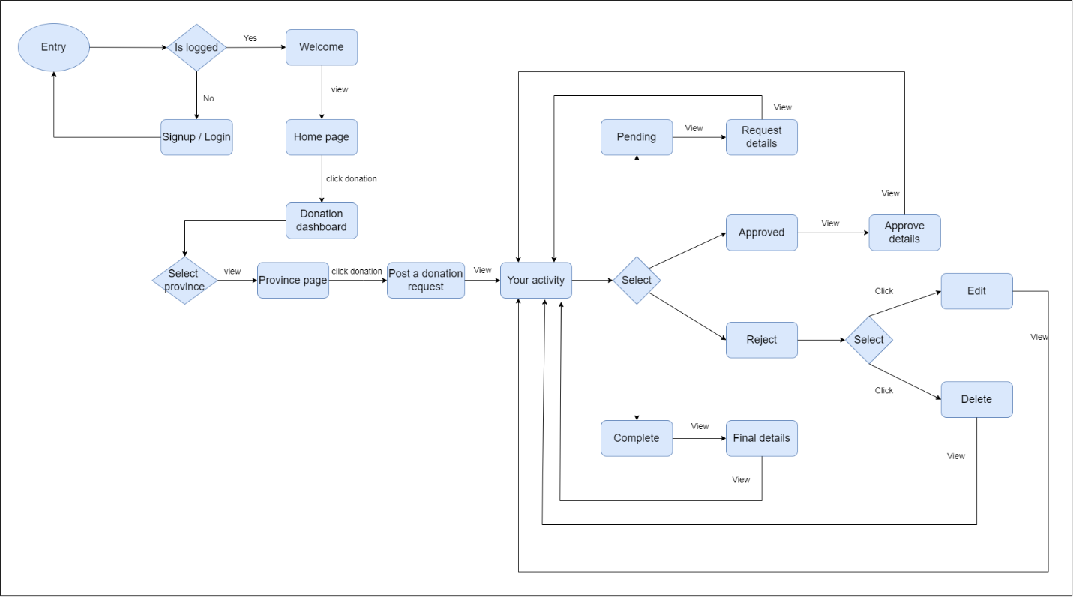

Fig 1.0: Process of Donation
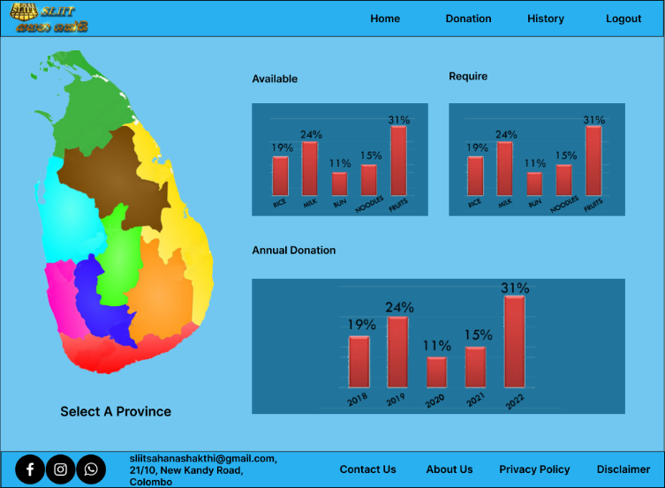
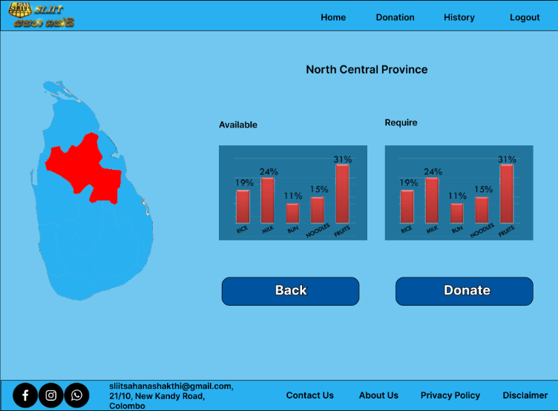

Fig 1.1: Donation Dashboard
Fig 1.2: Province Dashboard

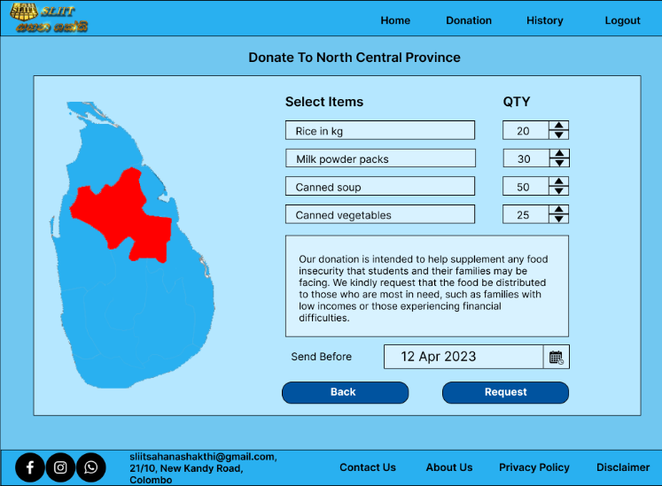
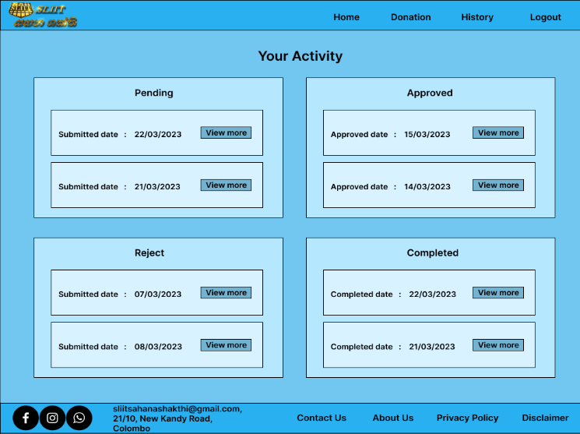

Fig 1.3: Donation Form
Fig 1.4: Activity Dashboard
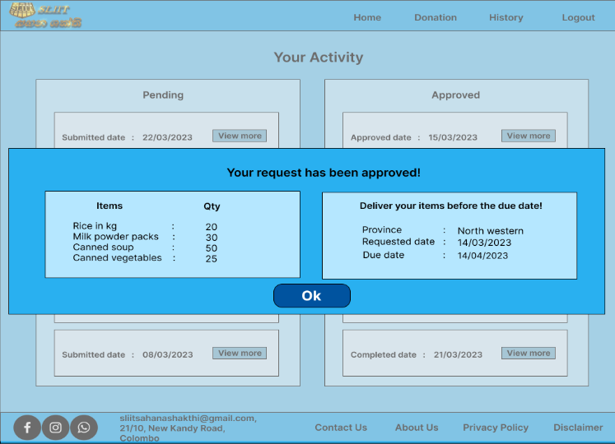
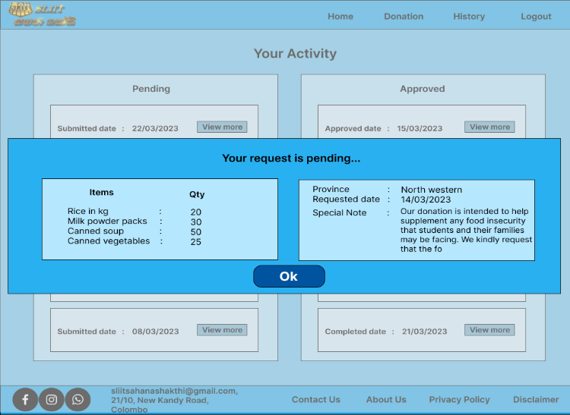

Fig 1.5: Activity Details
Fig 1.6: Activity Status

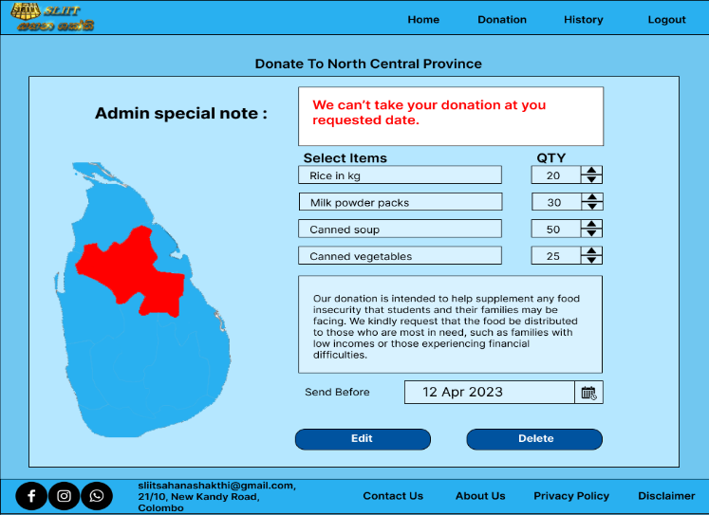
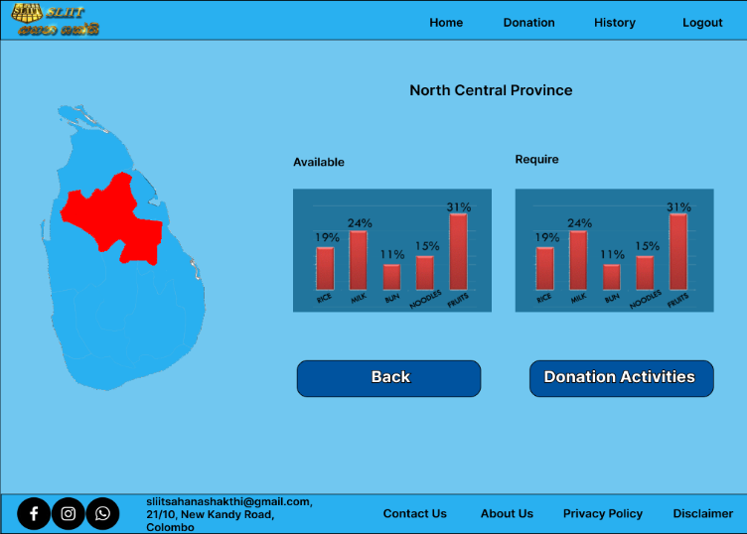

Fig 1.8: Province Dashboard for Admin
Fig 1.7: Edit Activity

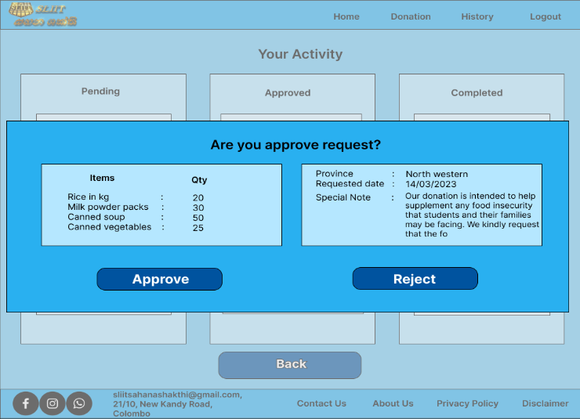
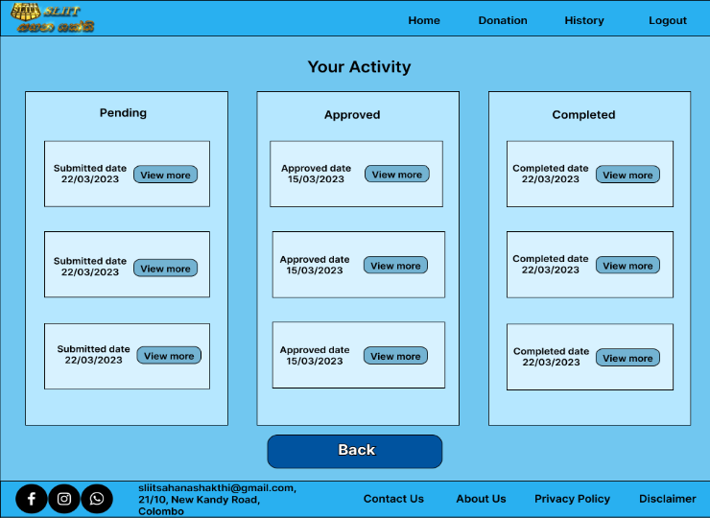

Fig 1.9: Admin Activity
Fig 2.0: Approve or Reject Donation request
Fig 2.1: Approve request
Fig 2.2: Completed Donation Status

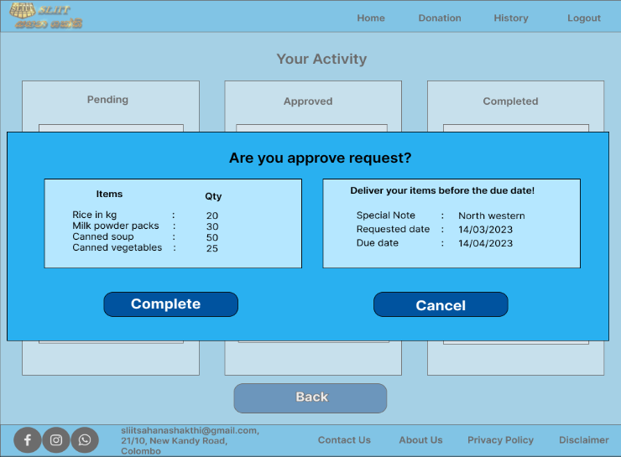
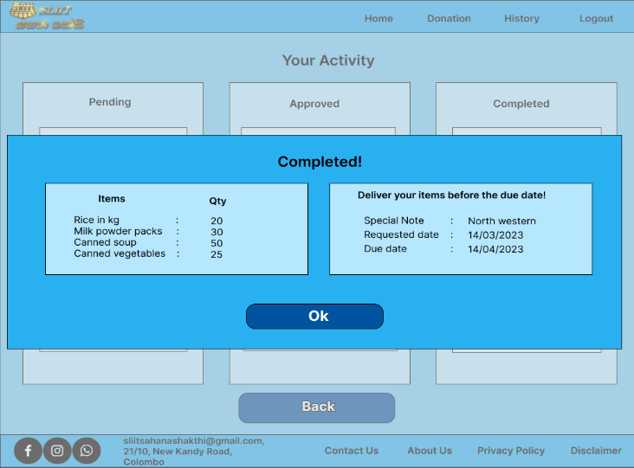

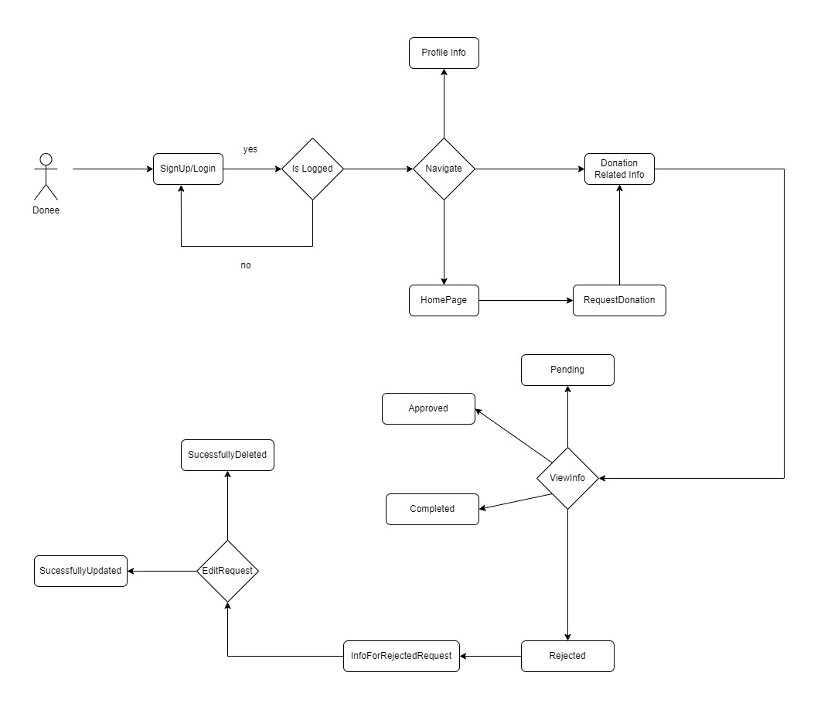

Fig 2.3: Flowchart for Donne

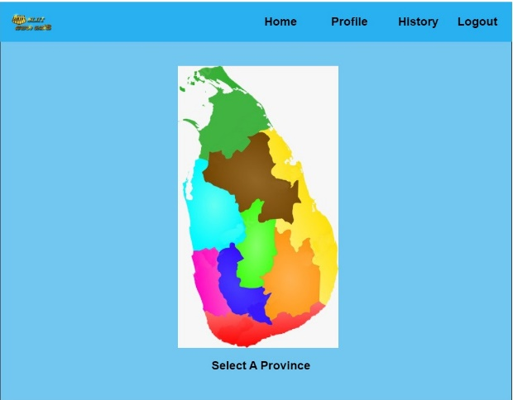
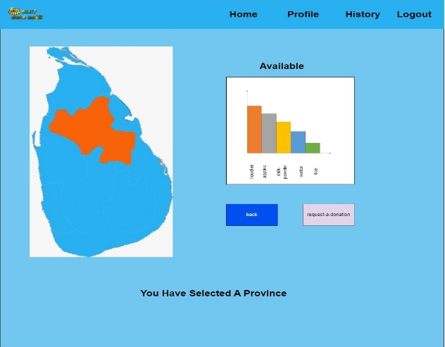

Fig 2.4: UI for selecting province
Fig 2.5: UI for a selected province

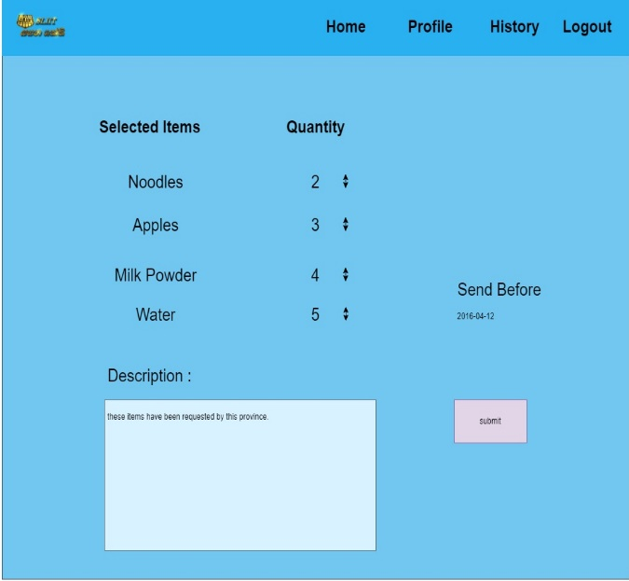
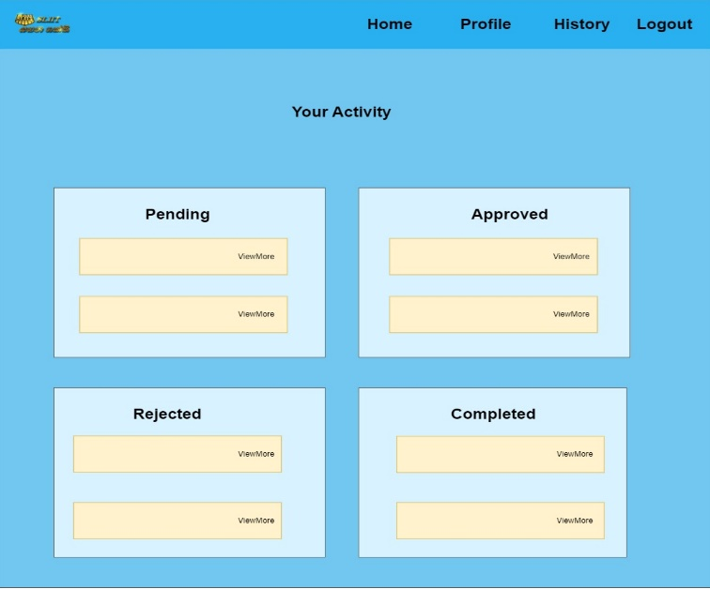

Fig 2.6: UI for requesting donation
Fig 2.7: Displays state of the request

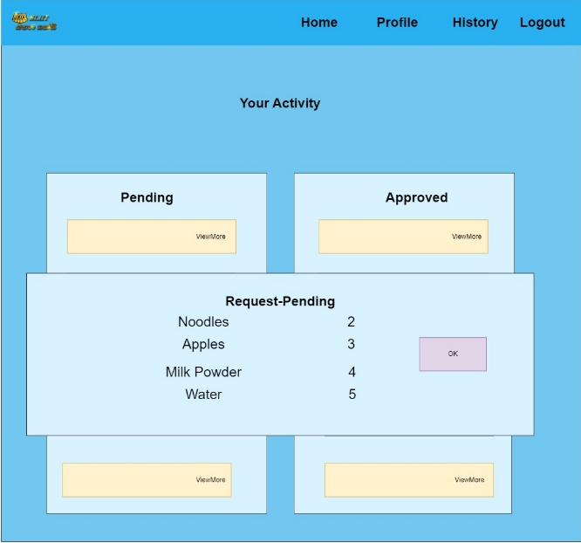
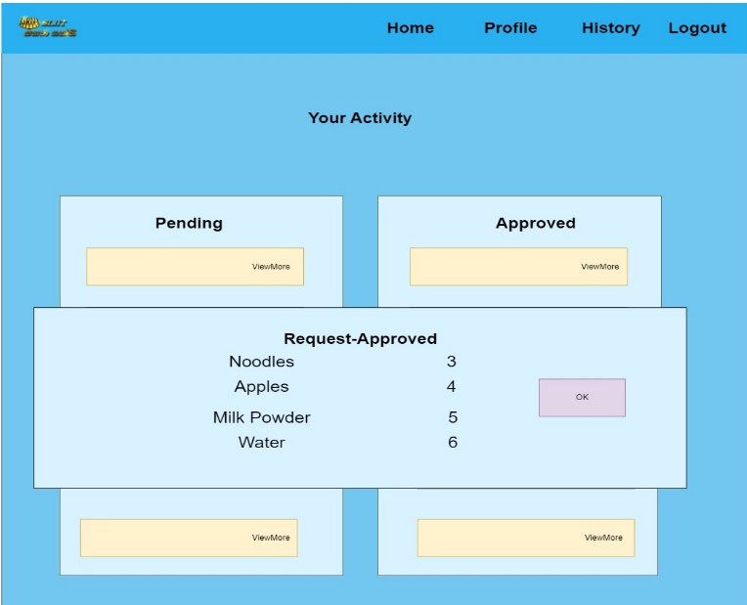

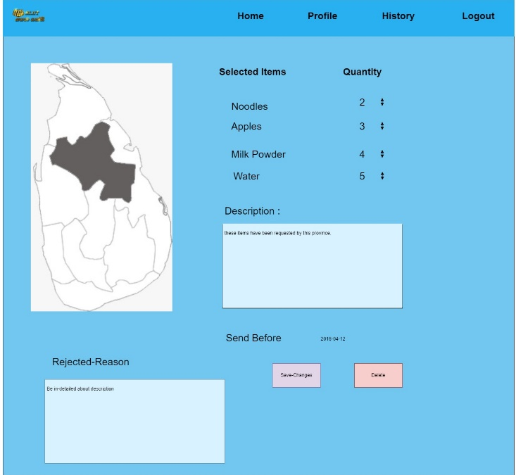
Fig 2.8: Information for Pending
Fig 2.9: Information for Approved
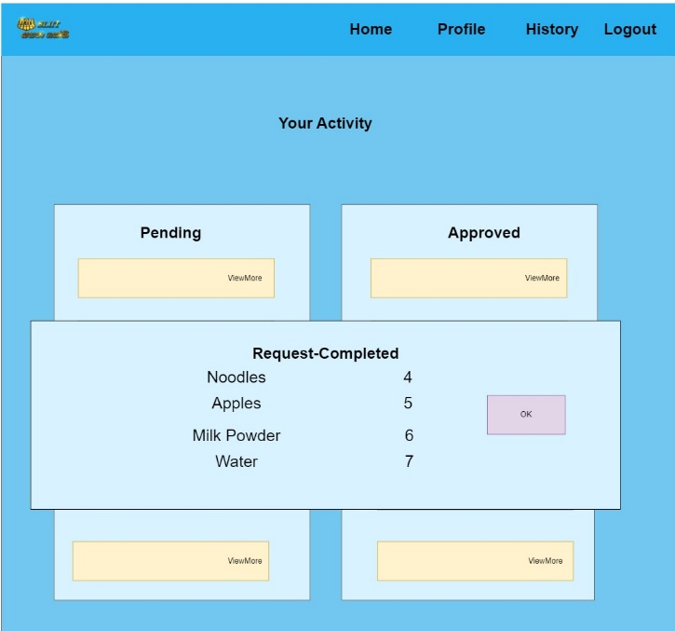

Fig 3.0: Information for Completed
Fig 3.1: Information for Rejected
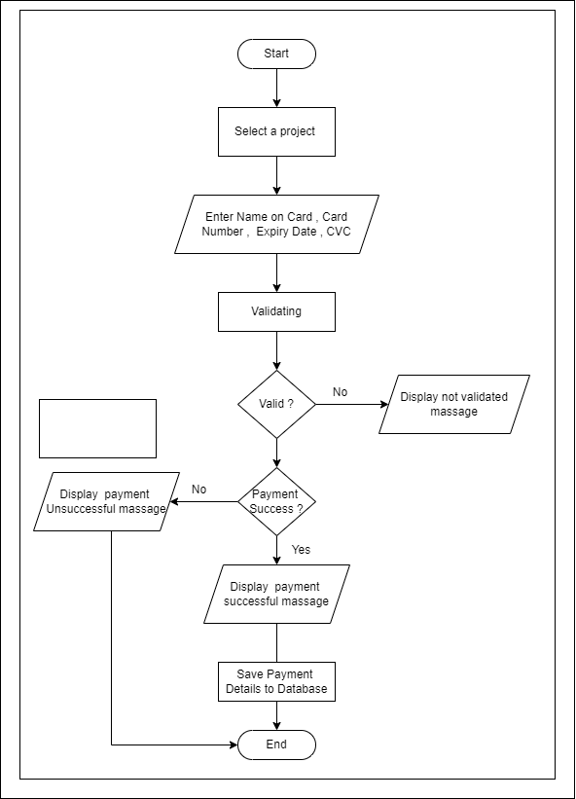

Fig 3.2: Payment Flow Chart

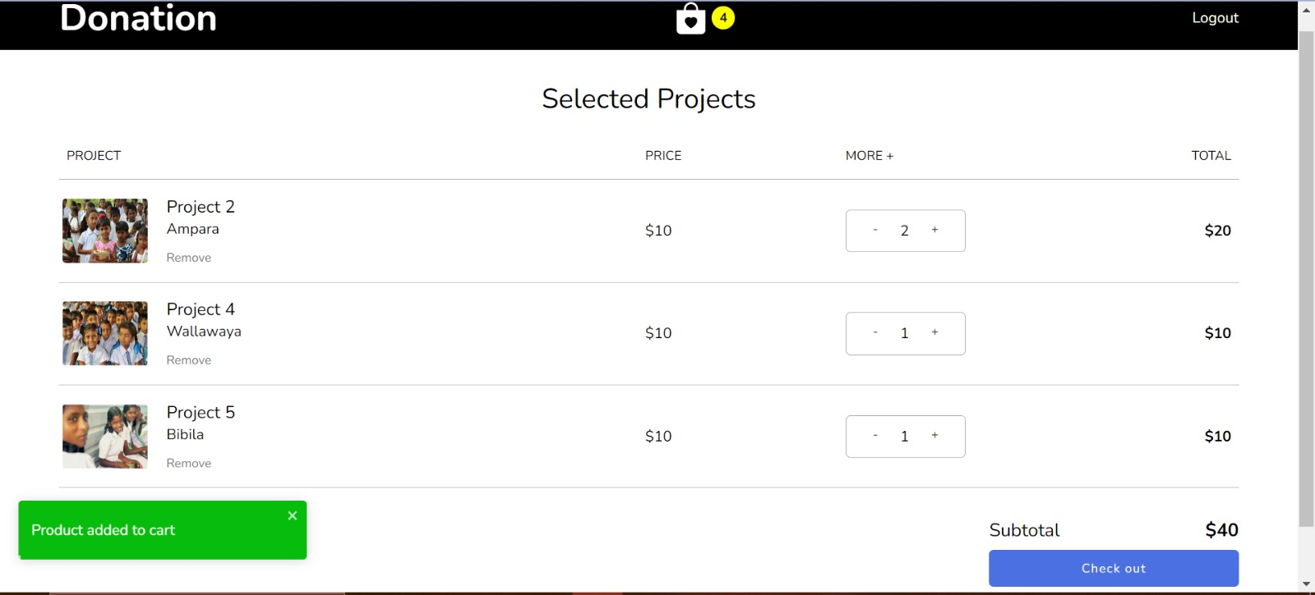

Fig 3.3: Cart View for Projects

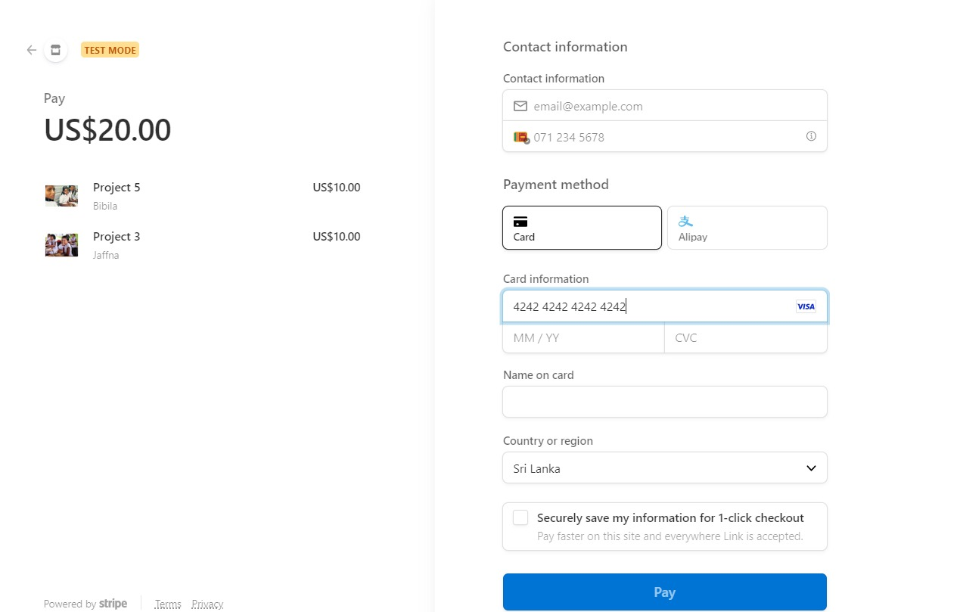

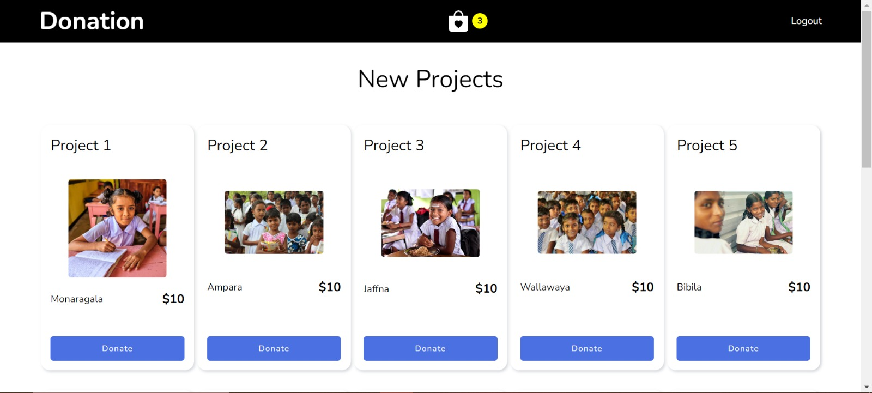

Fig 3.4: Payment View

Fig 3.5: View for New Projects

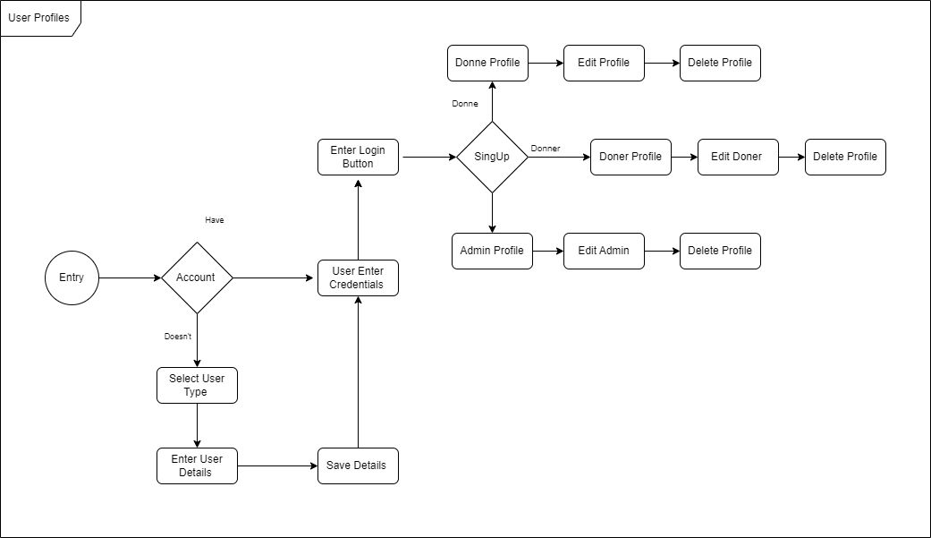

Fig 3.6: Flowchart for Common User Functions

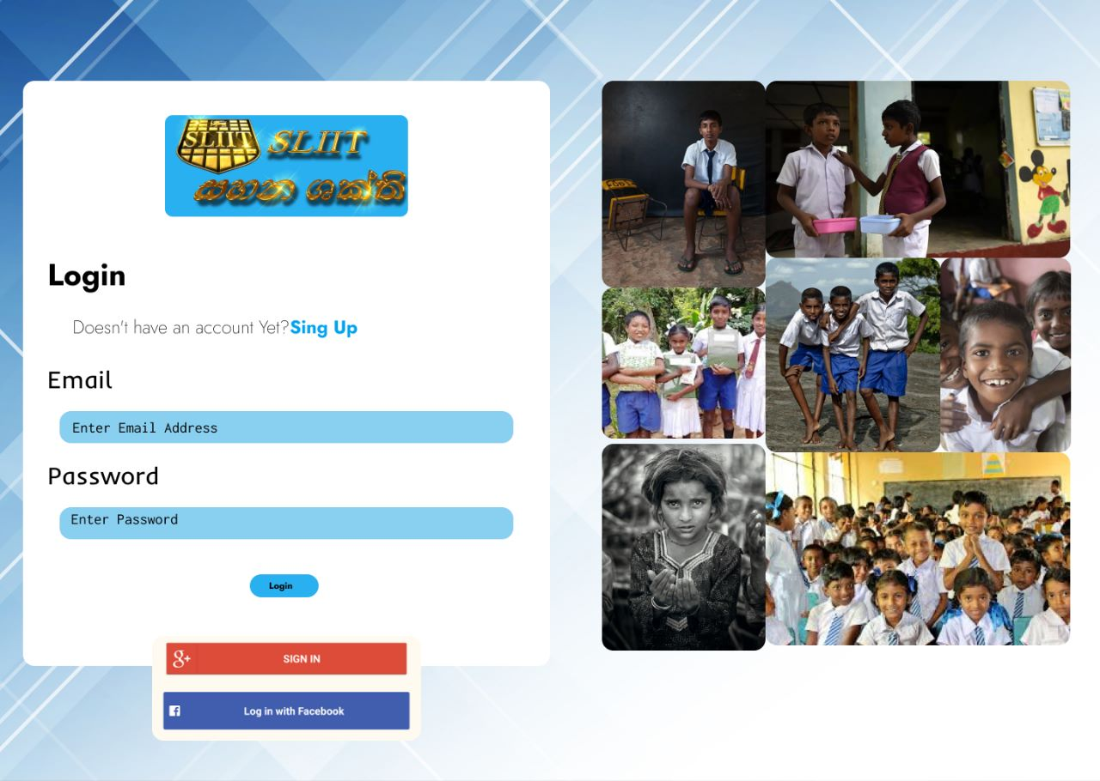

Fig 3.7: User Login

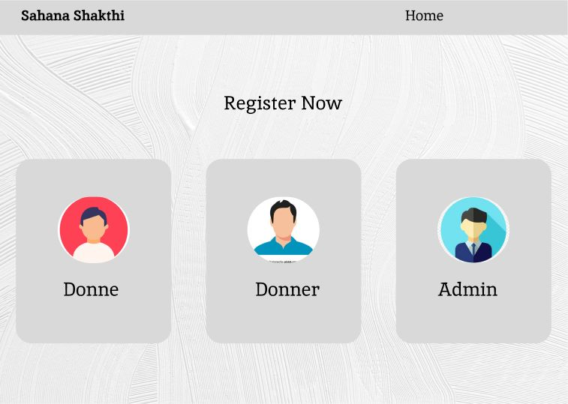

Fig 3.8: UI to select user type

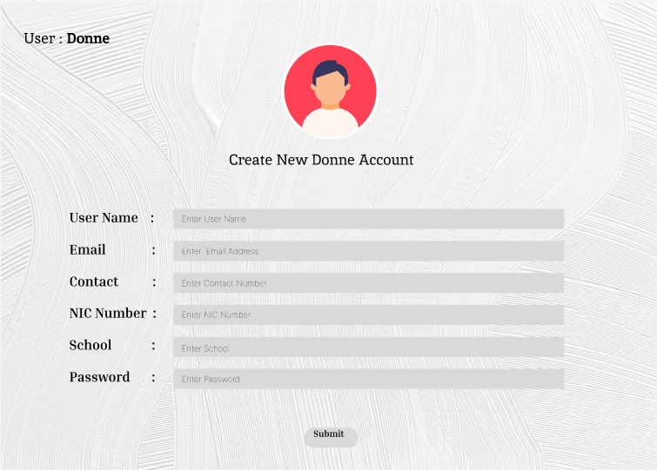

Fig 3.9: User Profile Information

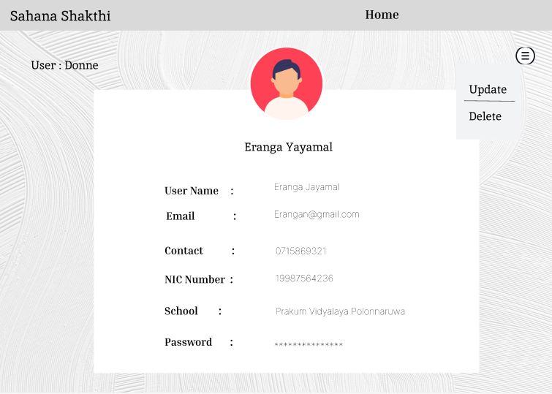

Fig 4.0: UI to select Update or Delete Profile

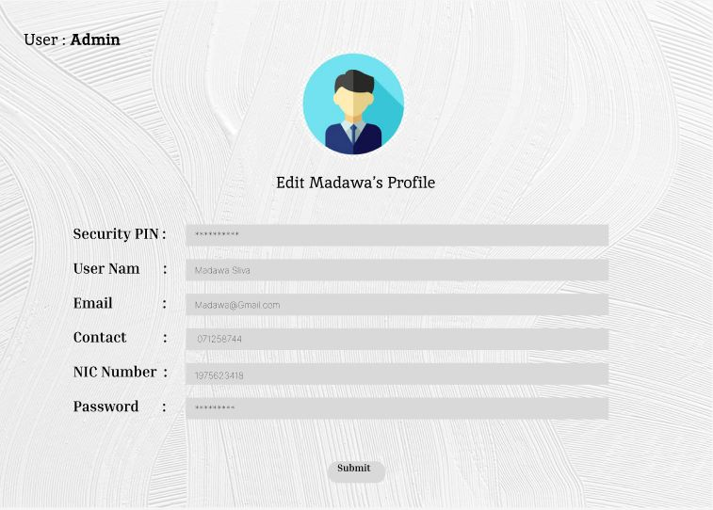

Fig 4.1: Editing User Profile

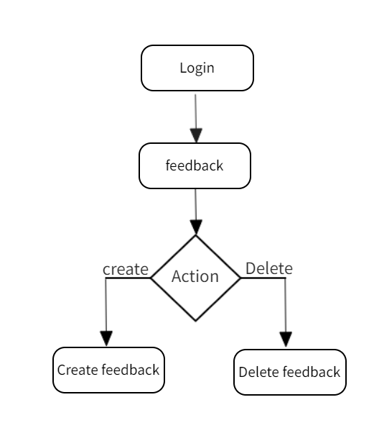

Fig 4.2: Flowchart for Feedback Functionality

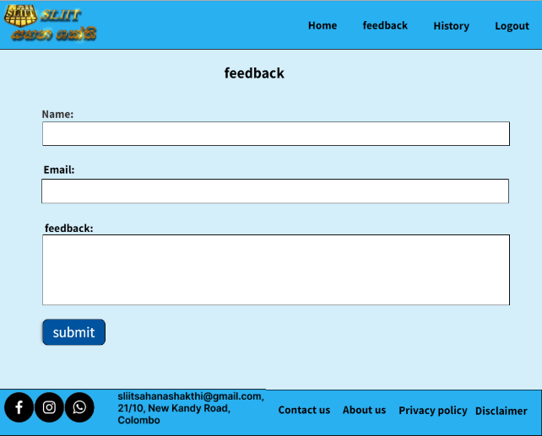

Fig 4.3: UI for Feedback

References

- Thamilini, J., Silva, K.D.R.R. and Jayasinghe, J.M.U.K., 2015. Prevalence of stunting among pre-school children food insecure rural households in Sri Lanka. Tropical Agricultural Research, 26(2)
- Rathnayake, R.M.L., Semasinghe, W.M. and Gunathilake, M.M., 2021. A Review of Empirical Literature on Maternal Factors and Child Malnutrition. Sri Lanka Journal of Social Sciences and Humanities, 1(2), p.59.
- Lowrey, John and Richards, Timothy J. and Hamilton, Stephen F., Food Bank Donations and Retail Pricing (December 6, 2020)
- VLAHOLIAS, Elisha, et al. Charity starts… at work? Conceptual foundations for research with businesses that donate to food redistribution organisations. Sustainability, 2015, 7.6: 7997-8021.
- Nan Ye, Lefa Teng, Ying Yu, Yingyuan Wang,“What's in it for me?”: The effect of donation outcomes on donation behavior,Journal of Business Research,Volume 68,Issue 3,2015,Pages 480-486,ISSN 0148-2963,https://doi.org/10.1016/j.jbusres.2014.09.015
- TARAR, Shweta, et al. ONLINE STUFF DONATION SYSTEM FOR NGO.
- SHELAR, Satish R.; SALVE, Stella Raju; KEDARI, Aishwarya Santosh. A Smart System for Donation Handling of Charitable Trusts and NGO's
- KAWALE, R. M., et al. Developing a Reliable Service System for Charity Donation.
- N. Alblihed, M. Almutairi, R. Almahmoud, S. Aladhadh and A. Alabdulatif, "Developing Food Charity Operations Management System," 2022 2nd International Conference on Computing and Information Technology (ICCIT), Tabuk, Saudi Arabia, 2022, pp. 93-96, doi: 10.1109/ICCIT52419.2022.9711609.
- S. P. Tiwari, G. Phonsa and P. Singh, "Study and Comparative analysis of Donation based websites," 2021 International Conference on Computing Sciences (ICCS), Phagwara, India, 2021, pp. 202-205, doi: 10.1109/ICCS54944.2021.00047.
- W. Lee, D. Kim and B. R. Jeon, "A Study on Blockchain Application in Donation Platform," 2021 21st ACIS International Winter Conference on Software Engineering, Artificial Intelligence, Networking and Parallel/Distributed Computing (SNPD-Winter), Ho Chi Minh City, Vietnam, 2021, pp. 284-286, doi: 10.1109/SNPDWinter52325.2021.00075.
- H. Saleh, S. Avdoshin and A. Dzhonov, "Platform for Tracking Donations of Charitable Foundations Based on Blockchain Technology," 2019 Actual Problems of Systems and Software Engineering (APSSE), Moscow, Russia, 2019, pp. 182-187, doi: 10.1109/APSSE47353.2019.00031.
- H. Wu and X. Zhu, "Developing a Reliable Service System of Charity Donation During the Covid-19 Outbreak," in IEEE Access, vol. 8, pp. 154848-154860, 2020, doi: 10.1109/ACCESS.2020.3017654.
- A. P. Junfithrana, E. Liani, M. Z. Suwono, D. Meldiana and A. Suryana, "Rice Donation System in Orphanage Based on Internet of Things, Raspberry-Pi, and Blockchain," 2018 International Conference on Computing, Engineering, and Design (ICCED), Bangkok, Thailand, 2018, pp. 235-238, doi: 10.1109/ICCED.2018.00053.
- I. A. Nuamah, L. Davis, S. Jiang and N. Lane, "Predicting donations using a forecasting-simulation model," 2015 Winter Simulation Conference (WSC), Huntington Beach, CA, USA, 2015, pp. 1880-1891, doi: 10.1109/WSC.2015.7408305.
- A. Sirikham, "Development of Multi-Purpose Donation Box based on the Internet of Things," 2021 9th International Electrical Engineering Congress (iEECON), Pattaya, Thailand, 2021, pp. 507-510, doi: 10.1109/iEECON51072.2021.9440294.
- A. F. Zambrano et al., "Donation Networks in Underprivileged Communities," in IEEE Transactions on Computational Social Systems, vol. 8, no. 1, pp. 76-85, Feb. 2021, doi: 10.1109/TCSS.2020.3037148.

